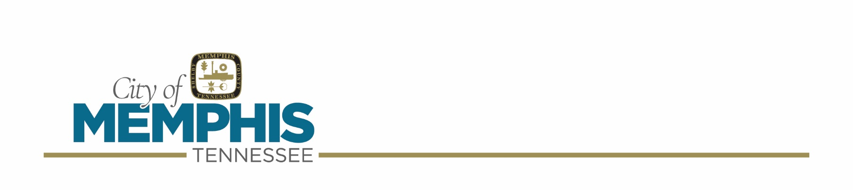
City of Memphis
Alcohol Commission Meeting Agenda
October 21, 2026

- Call to Order

- Roll Call

- Approval of the minutes from the previous meeting (October 7, 2026)

- Special Beer Applicant(s):

- Molly Morrison – 0 Broad Avenue – “Broad Ave Art Walk”
Date(s): October 24, 2026
Time: 10:00 a.m. – 5:00 p.m.
Rain Date: October 25, 2026
Sponsoring Organization: EventOps LLC
Purpose of funds: For Profit; 2 booth(s)
Continued from the October 7, 2026 A C Meeting
(Account # MEM-BEER-00034-A)

- Molly Morrison – Overton Park Greensward – “MEMREN”
Date(s): October 31 – November 1, 2026
Time: 10:00 a.m. – 10:00 p.m.
Rain Date: N/A
Sponsoring Organization: EventOps LLC
Purpose of funds: For Profit; 4 booth(s)
Continued from the October 7, 2026 A C Meeting
(Account # MEM-BEER-00035-A)

- Molly Willmott – 2101 Madison Avenue – “Overton Square Oktoberfest 2026”
Date(s): October 24, 2026
Time: 12:00 p.m. – 5:00 p.m.
Rain Date: N/A
Sponsoring Organization: Events Squared LLC
Purpose of funds: For Profit; 1 booth(s)
(Account #MEM-BEER-00038-A)

- Molly Willmott – 1350 Concourse Avenue – “Crafts & Drafts Holiday Market”
Date(s): November 7, 2026
Time: 10:00 a.m. – 4:00 p.m.
Rain Date: N/A
Sponsoring Organization: Memphis Flyer and Crosstown Arts
Purpose of funds: Charitable; 3 booth(s)
(Account #MEM-BEER-00039-A)

- Margaret Tong – 1368 Jefferson Avenue – “Bao Toan Kitchen & Bar”
Date(s): October 25, 2026
Time: 11:00 a.m. – 6:00 p.m.
Rain Date: N/A
Sponsoring Organization: Crosstown Memphis CDC
Purpose of funds: For Profit; 1 booth(s)
(Account #MEM-BEER-00043-A)

- Matthew Arehart – 4577 Billy Maher Road – “St. Columba Episcopal Camp and Retreat Center”
Date(s): October 24, 2026
Time: 6:00 p.m. – 9:00 p.m.
Rain Date: N/A
Sponsoring Organization: St. Columba Episcopal Camp and Retreat Center
Purpose of funds: Charitable; 1 booth(s)
(Account #MEM-BEER-00048-A)

- Liquor Store(s) Applicants

Liquor Store(s) Transfer of Ownership:

- Sukhwinder Singh – 2865 Kirby Road – Kirby Wine and Spirits Inc – dba – “Kirby Wine and Spirits Inc”
(Account #MEM-COC-00002)

- Navjot Singh – 3249 North Watkins Street – Frayser Liquors LLC – dba – “Heart of Frayser Liquor”
(Account # MEM-COC-00004)

- Violation(s):

The following location(s) are in violation of A C Rule C4, C5, D4 (NO) priors:

- Paper Gamoom – 3003 Lamar Avenue – Three Diamonds LLC – dba – “Three Diamonds Food Mart” – Citation(s) #947597, OS419930
Date of Violation(s): July 27, 2026
Date Permit Approved: July 5, 2023
Officer(s): Croom #14039, Irby #9892, Martin #0410
(Account #T29895)

The following location(s) are in violation of A C Rule C5, D4 (NO) priors:

- Mohammad Ali, Arifur Arif, FNU Savrina, MD H. Orrashid and MD Ullaha – 2337 Airways Blvd. – XXL Enterprise, Inc. – dba – “Valero Express” – Citation(s) #979494
Date of Violation(s): July 8, 2026
Date Permit Approved: August 16, 2017
Officer(s): Croom #14039, Martin #0410
(Account #T15230)

- The Following Person(s) has Applied to Sell Beer for “ON” Premise Consumption:

- Divya Varma, Dev Varma, Lisa Jehl, Louis Jehl, Andrew Mathewes and Susan Springfield – 2166 Central Avenue – Good Chimes LLC – dba – “Stomping Grounds”
Continued from the October 7, 2026 AC Meeting
(Account #MEM-BEER-00016-A)

- Jon Rasmussen, Cory Likens and Timothy Quinn, Jr. – 535 South Highland Street – Cat Clubs LLC – dba – “Country Club”
(Account # MEM-BEER-00041-A)

- The Following Person(s) has Applied to Sell Beer for “OFF” Premise Consumption

- Sharif Abdulaziz – 1245 North Hollywood Street – B-52 LLC – dba – “B-52”
Continued from the October 7, 2026 AC Meeting
(Account #MEM-BEER-00027-A)

- Anas Owda – 6031 Knight Arnold Road Extended – AM Express Market Inc. – dba – “Z Market”
No newspaper ad printed/website publication
(Account # MEM-BEER-00037-A)

- Dereje Ayele – 2725 Range Line Road – Express Checkout LLC – dba – “Express Checkout LLC”
Negative sign check
(Account # T37723)

- Rafat Morshid – 4210 Overton Crossing Street – Sammen LLC – dba – “Sammen Food Mart”
(Account # MEM-BEER-00042-A)

- The Following Person(s) has Applied to Sell Beer for “OFF 10%” Premise Consumption:

- Ramzi Murshed – 2166 East Raines Road – dba – “Raines Mini Mart”
(Account # MEM-BEER-00044-A)

- New Business

- Old Business

- Adjournment

- C4 – Only authorized personnel, meeting requirements of TCA 57-5-301(a)(1), shall be left in charge of a beer establishment to sell or serve beer to customers. The Memphis Alcohol Commission issues proof of compliance in the form of beer vendor card available through the City Permit Office for accost of $21.00.

- C5 – No beer shall be sold or served to persons under legal age. A person must be 21 years of age to buy, consume or possess beer. The burden of ascertaining the correct age of minor customers shall be upon the owner, operator, and employees of the business.

- D4 – Proof of legal age is required of all customers before any alcoholic beverages are served or sold to such persons.

