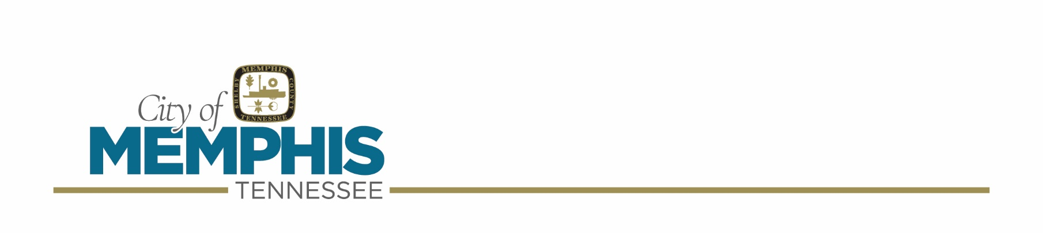
City of Memphis
Alcohol Commission Meeting Agenda
September 2, 2026

- Call to Order

- Roll Call

- Approval of the minutes from the previous meeting (August 19, 2026)

- Special Beer Applicant(s):

- Brian M. Bazar – 1300 Mud Island Drive – “Wolf River On The Greenway”
Date(s): October 2, 2026
Time: 5:00 p.m. – 8:00 p.m.
Rain Date: N/A
Sponsoring Organization: Wolf River Conservancy
Purpose of funds: For Profit/Charitable; 1 booth(s)
(Account #T2409)

- Ashley Grady – Martyrs Park – “The Luxury PinkNiq”
Date(s): September 19, 2026
Time: 2:00 p.m. – 7:30 p.m.
Rain Date: N/A
Sponsoring Organization: N/A
Purpose of funds: For Profit; 2 booth(s)
(Account #T33279)

- Lakeesa Rayford Mitchell – Medical District Park – “Taste of the District”
Date(s): October 6, 2026
Time: 4:00 p.m. – 6:00 p.m.
Rain Date: October 13, 2026
Sponsoring Organization: Memphis Medical District Collaborative
Purpose of funds: Charitable; 2 booth(s)
(Account #T37564)

- Ashley McEntire – 752 South Cooper Street – “Aldo’s Pizza Fest”
Date(s): September 19, 2026
Time: 9:00 a.m. – 6:00 p.m.
Rain Date: September 20, 2026
Sponsoring Organization: Aldo’s Pizza Pies
Purpose of funds: For Profit; 1 booth(s)
(Account #T35716)

- Violation(s):

The following location(s) are in violation of A C Rule C5, D4 (WITH) priors:

- Ayad Eedha – 5816 Mount Moriah Road – Save N Go Mart, LLC – dba – “Save N Go Mart” – Citation(s) #968723
Date of Violation(s): June 7, 2026
Date Permit Approved: June 16, 2026
Prior Violation(s): March 5, 2025 (C5)
March 30, 2023 (C5, D4)
Officer(s): Croom #14039, Irby #9892, Martin #0410, Ward #0502
(Account #T25625)
The following location(s) are in violation of A C Rule C4 (WITH) priors:

- MD Haque, Abdullah Mamun, and Dewan Rahman – 4311 New Allen Road – Hope Express, Inc. – dba – “Amazing Express” – Citation(s) #OS-428922
Date of Violation(s): June 29, 2026
Date Permit Approved: April 21, 2021
Prior Violation(s): April 20, 2023 (C4, C5, D4)
Officer(s): Croom #14039
(Account #T25335)

- Dahan Altareb and Mohamed Sharhan – 2231 South Third Street – Third St Hop In, Inc. – dba – “Third St Hop In” – Citation(s) #OS-428916
Date of Violation(s): June 13, 2026
Date Permit Approved: August 5, 2015
Prior Violation(s): May 20, 2025 (C5, D4)
Officer(s): Croom #14039, Irby #9892, Ward #0502
(Account #T7002)
The following location(s) are in violation of A C Rule C5 (WITH) priors:

- Nabil Haimed and Abdullah Al Gumaei – 3467 Range Line Road – Frayser Discount Mart, LLC – dba – “Frayser Discount Mart” – Citation(s) #968724
Date of Violation(s): June 29, 2026
Date Permit Approved: November 17, 2021
Prior Violation(s): April 21, 2025 (C1, C5, D4)
Officer(s): Croom #14039, Martin #0410, Ward #0502
(Account #T26238)

- Annette S. Hamilton – 9 West Mallory Avenue – dba – “South Memphis Grocery” – Citation(s) #1020027
Date of Violation(s): June 13, 2026
Date Permit Approved: August 18, 1993
Prior Violation(s): May 22, 2025 (C5)
Officer(s): Croom #14039, Martin #0410, Ward #0502
(Account #BR2564)
The following location(s) are in violation of A C Rule C4, C5, D4 (NO) priors:

- Jaber Ghasan – 3546 Ridgemont Road – dba – “Raleigh Quick Stop” – Citation(s) #968722, OS-428921
Date of Violation(s): June 29, 2026
Date Permit Approved: January 5, 2022
Officer(s): Croom #14039, Martin #0410, Ward #0502
(Account #T26853)

- The Following Person(s) has Applied to Sell Beer for “ON” Premise Consumption:

- David Yancey III – 485 North Hollywood Street – Hollywood LLC – dba – “Hollywood”
(Account #T37640)

- Janice Crawford – 358 North Main Street, Suite 101 – Jazzy’s Entertainment LLC – dba – “Jazzy’s Entertainment LLC”
Continued from August 19, 2026 AC Meeting
(Account #T37624)

- Matthew Adam Schechter – 335 South Hollywood Street – Volume Services, Inc. – dba – “Simmons Bank Liberty Stadium”
(Account #T37587)

- The Following Person(s) has Applied to Sell Beer for “OFF” Premise Consumption

- Farhad Salih – 2768 Park Avenue – dba – “Save Moor Express”
(Account #T37565)

- New Business

- Old Business

- Adjournment

- C4 – Only authorized personnel, meeting requirements of TCA 57-5-301(a)(1), shall be left in charge of a beer establishment to sell or serve beer to customers. The Memphis Alcohol Commission issues proof of compliance in the form of beer vendor card available through the City Permit Office for accost of $21.00.

- C5 – No beer shall be sold or served to persons under legal age. A person must be 21 years of age to buy, consume or possess beer. The burden of ascertaining the correct age of minor customers shall be upon the owner, operator, and employees of the business.

- D4 – Proof of legal age is required of all customers before any alcoholic beverages are served or sold to such persons.

