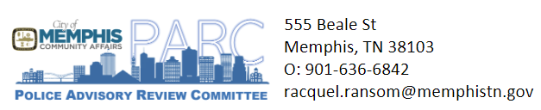

**AGENDA**

**Police Advisory Review Committee (PARC)**

125 N. Main St, City Council Conference Room, 5th Floor

***Thursday, October 24,2024***

4:00 pm

1. Welcome | Director Reginald Boyce
2. Ordinance | Atty Mary Craft Grambergs
   1. Overview of ordinance
   2. Explanation of role of elected officials
3. Election of Officers | Director Reginald Boyce
   1. Chairperson
   2. Alternative Chairperson
   3. Secretary
4. Committee Selection | Racquel Ransom
   1. Communication and Recommendation Commitee
   2. Outreach Committee
   3. Web Design Committee
5. Vote to select future board meetings
   1. 1st Wednesday quarterly meetings
   2. 2nd Thursday quarterly meetings
   3. 4th Wednesday or Thursday quarterly meeting

**-Adjournment-**